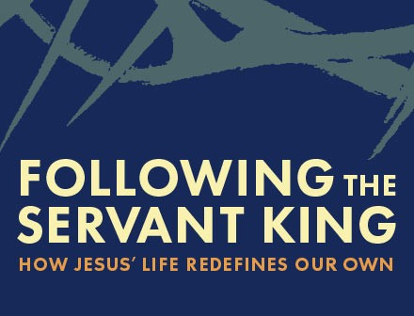
Chief Cornerstone

Text: Mark 11:27 – 12:12

Context: Jesus has made His Triumphal entry into Jerusalem with the disciples (11:1-14). He has literally cleaned house by overturning the money changers’ tables and driving them out of His Father’s house (v15-18). Now He’s returning to the temple and they are waiting for Him (v27). In this week’s passage we’ll see how God begins to fulfill another messianic prophecy, “The stone which the builders rejected, this became the chief cornerstone.” (v10). Once again we’ll see how following the Servant King redefines everything.

Read Mark 11:27 – 12:12

- Jesus’ authority baffles the religious. (Mark 11:27-28)
What is the significance of the priests confronting Jesus in the temple? Why couldn’t the priests, the most religious people of the day, recognize Jesus? What was the true intention of the priests in confronting Jesus (see v18)?

- Jesus questions the authority of man. (Mark 11:29-33)
Why does Jesus answer questions with a question? Who did the priests and scribes really fear according to verse 31-32 and why? How does Jesus actually answer their “authority” question in these verses (29-33)?

- Jesus and the “chief cornerstone.” (Mark 12:1-12)
Read the parable (12:1-11) and identify the following characters: 1) Vineyard Owner; 2) the “vine-growers”; 3) “the slaves” (v2,4,5); and 4)“a beloved son” (v6). How is Jesus’s mission (the gospel) alluded to in this parable (hint v6-8)? How does this parable answer their question about Jesus’ authority?

BIG IDEA: Jesus is the Chief Cornerstone. (Mark 12:10-11)
Like the vine-growers in the parable, the priests and religious leaders wanted the things of God (“the inheritance” in verse 7) but not a relationship with God. They wanted a relationship, but one without authority that “invaded their space.” Following Jesus requires us to accept Him as our Chief Cornerstone – our Authority. It’s up to us to submit to the Servant King’s authority that redefines our lives.

What comes to mind when you hear the word “authority”?

How has Jesus’ authority challenged your faith recently? How has it “invaded your space”?

What can the group do this week to help you follow Jesus as your Chief Cornerstone?

Next Week’s Passage: Mark 12:13-27 / “Questions for Jesus”

